P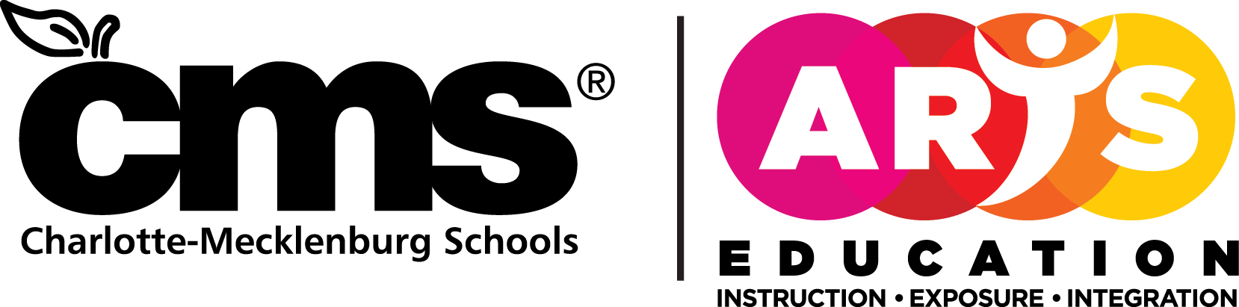
HONORS ORCHESTRAS
4421 Stuart Andrew Boulevard
Suite #450A
Charlotte, NC 28217 (980) 343-2697

Dear Parents September 2019
Orchestra students in grades 5-12 are invited to audition for the Charlotte Mecklenburg Schools Honors Orchestras. The auditions will be held on Saturday, November 23, 2019 at East Mecklenburg High School. Students will meet their teachers at 8:15am and auditions will begin following a brief director meeting at 8:30am. The audition is free of charge, however, each student must register with their director in early October. All auditions must be made in person. No audio or videos will be accepted. Students are responsible for their own music, instruments, and personal belongings while at the audition. Audition numbers will be assigned ahead of time. Keep in mind, however, that this audition is open to all middle and high schools in CMS and may take several hours. Instrumentalists, especially violinists, should be prepared to wait.

Audition results will be sent to your child’s orchestra director. The concert music and acceptance forms will be given to your child through your child’s director. This information will provide details of the event. A music reading session will be held Thursday, January 23, 2020 at Northwest School of the Arts (high school rehearsal is from 5:30-7:00 pm, middle school rehearsal is from 7:00-8:30 pm).The clinic will be held Friday-Saturday, February 7-8, 2020, at Waddell Language Academy. Please note that ALL students in CMS Honors Orchestras MUST attend ALL rehearsals and clinics in order to participate in the experience. Students who audition and do not complete the requirements will not be allowed to audition the following year.

Please encourage your child to audition for this rich musical experience. If you have any questions, please contact your child’s director first. If you have questions, your school’s orchestra director cannot answer, please contact Matt Wilson (for high school auditionees) at Mallard Creek High School (980-343-1341), Sarah Lancaster (for middle school auditionees) at Randolph Middle School (980-343-6700), or Amanda Turner at East Meck (980-343-6430).

Amanda Turner, Audition Chairperson
Matt Wilson, Sarah Lancaster, Alice Cuviello, and Tom Lajoie
Event Chairs

